**Practical No. 6**

1. **Working with ListView, SpinnerView and**

**autoCompleteTextView.**

1. **ListView**

**Designing UI**

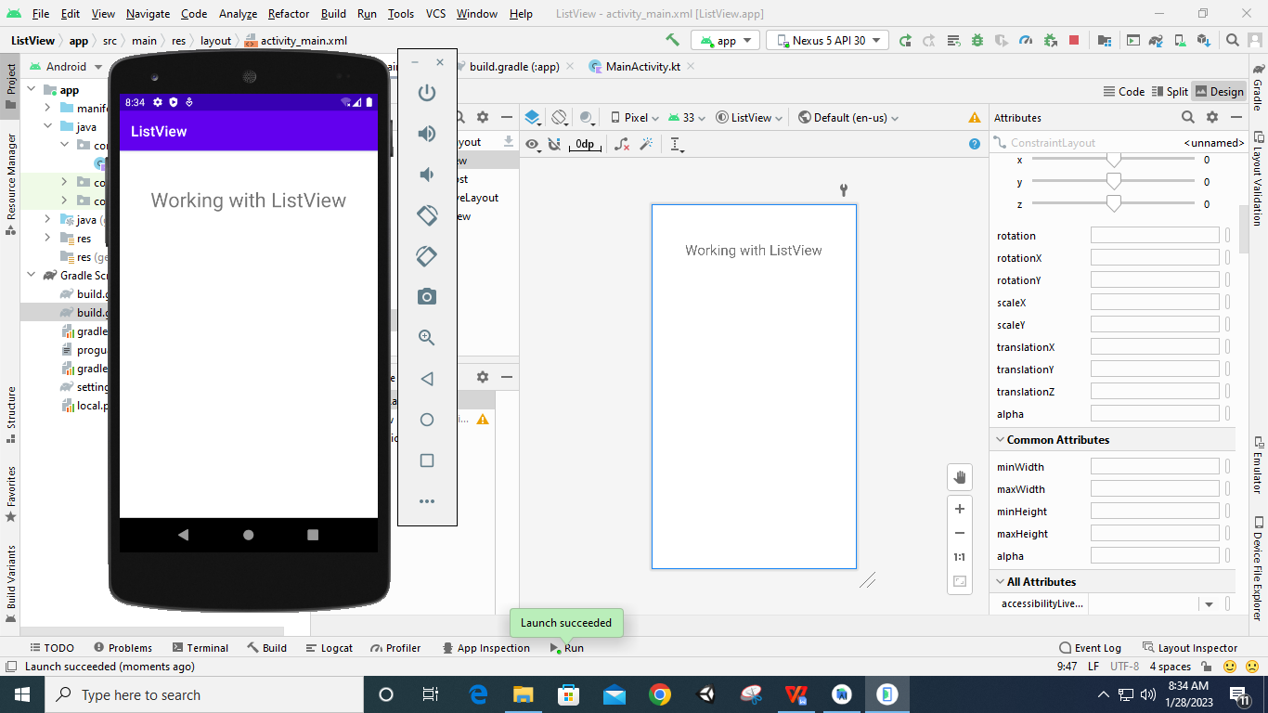

**Code:**

**String.xml**

<**resources**>  
 <**string name="app_name"**>ListViewDemo</**string**>  
 <**string-array name="programming_languages"**>  
 <**item**>C++</**item**>  
 <**item**>JAVA</**item**>  
 <**item**>Python</**item**>  
 <**item**>Kotlin</**item**>  
 </**string-array**>  
</**resources**>

**MainActivity.kt**

**package** com.example.listview  
  
**import** androidx.appcompat.app.AppCompatActivity  
**import** android.os.Bundle  
**import** android.view.View  
**import** android.widget.AdapterView  
**import** android.widget.ArrayAdapter  
**import** android.widget.ListView  
**import** android.widget.Toast  
  
**class** MainActivity : AppCompatActivity(), AdapterView.OnItemClickListener {  
 **override fun** onCreate(savedInstanceState: Bundle?) {  
 **super**.onCreate(savedInstanceState)  
 setContentView(R.layout.*activity_main*)  
  
 **var** list1: ListView? = **null  
 var** adapter: ArrayAdapter<String>? = **null  
  
 var** itemList: Array<String>  
 itemList = getResources().getStringArray(R.array.*programming_languages*)  
  
 list1 = findViewById(R.id.*listview*)  
 adapter =  
 ArrayAdapter(**this**, android.R.layout.*simple_list_item_1*, android.R.id.*text1*, itemList)  
  
 list1?.setAdapter(adapter)  
  
 list1?.*onItemClickListener* = **this** }  
 **override fun** onItemClick(parent: AdapterView<*>?, view: View?, position: Int, id: Long) {  
 **var** item=parent?.getItemAtPosition(position) **as** String  
 Toast.makeText(*applicationContext*,**"Item Selected is "**+item,Toast.*LENGTH_LONG*).show()  
 }  
}

**Output:**

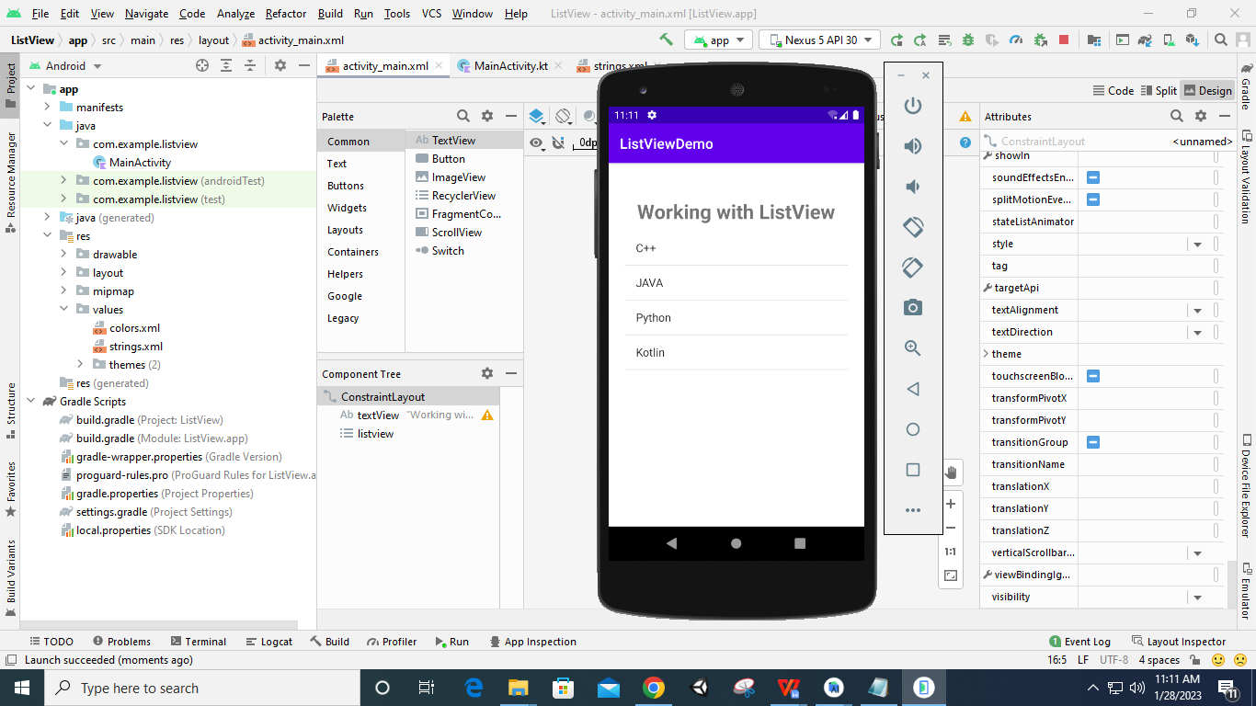

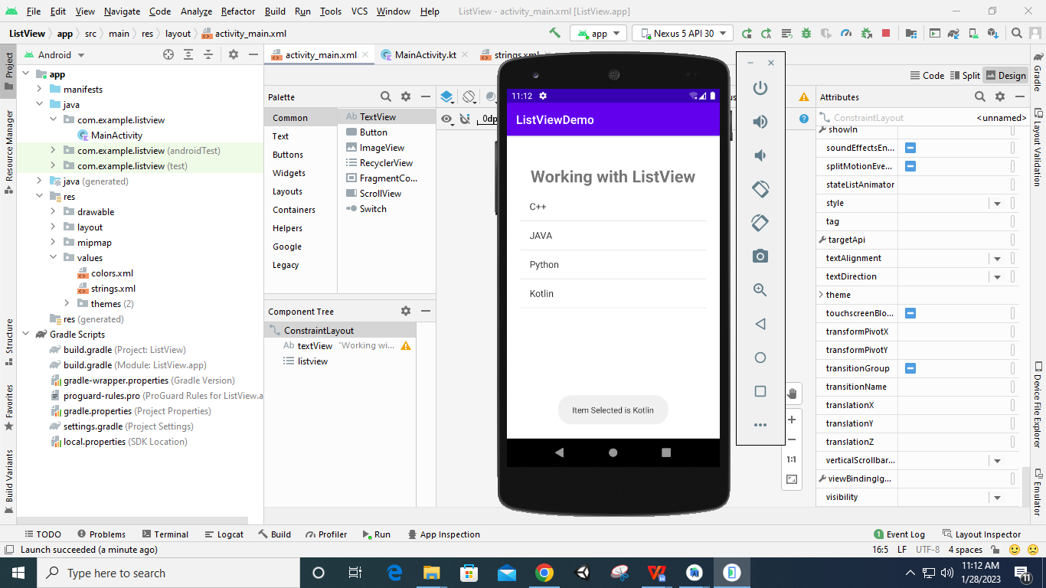

1. **autoCompleteTextView.**

**Designing UI**

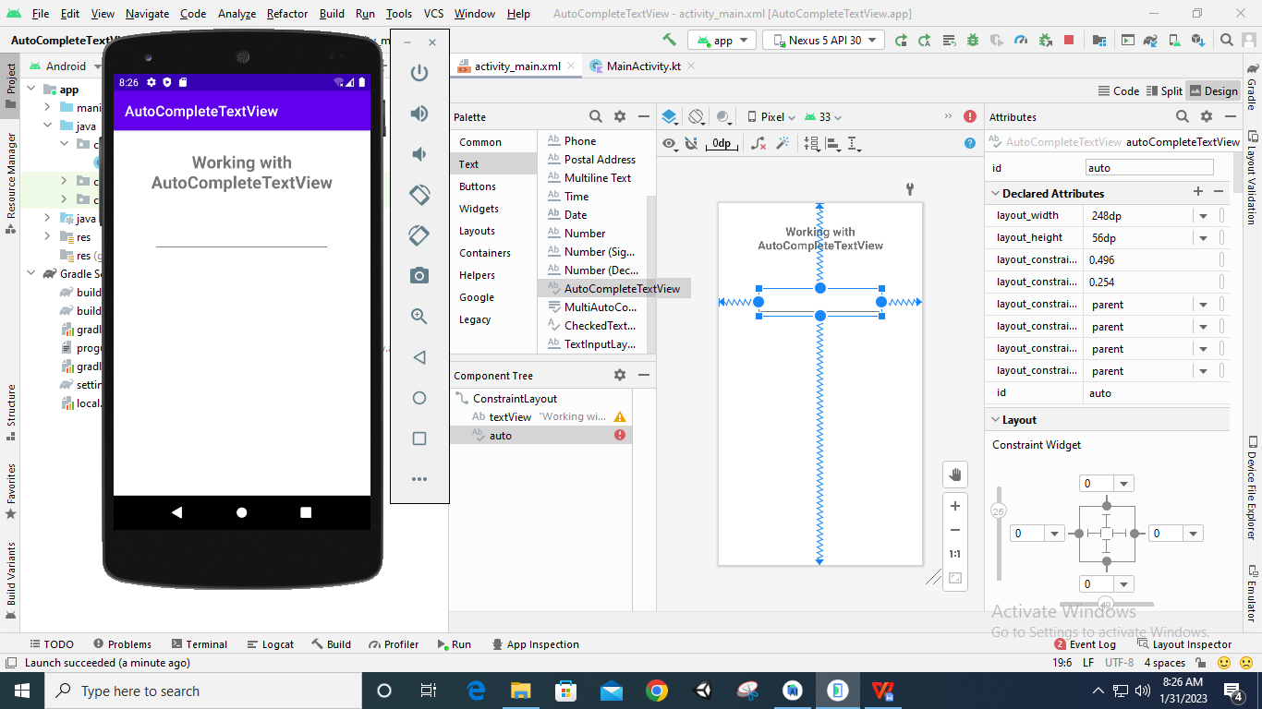

**Code:**

**package** com.example.autocompletetextview  
  
**import** androidx.appcompat.app.AppCompatActivity  
**import** android.os.Bundle  
**import** android.widget.ArrayAdapter  
**import** android.widget.AutoCompleteTextView  
  
**class** MainActivity : AppCompatActivity(){  
 **override fun** onCreate(savedInstanceState: Bundle?) {  
 **super**.onCreate(savedInstanceState)  
 setContentView(R.layout.*activity_main*)  
  
 **var** languages=*arrayOf*(**"Kotlin"**,**"Python"**,**"Java"**,**"C++"**,**"C"**)  
 **var** adapter= ArrayAdapter(*applicationContext*,android.R.layout.*simple_dropdown_item_1line*,languages)  
 **var** autotext:AutoCompleteTextView=findViewById(R.id.*auto*)  
  
 autotext.*threshold*=2  
 autotext.setAdapter(adapter)  
 }  
}

**Output:**

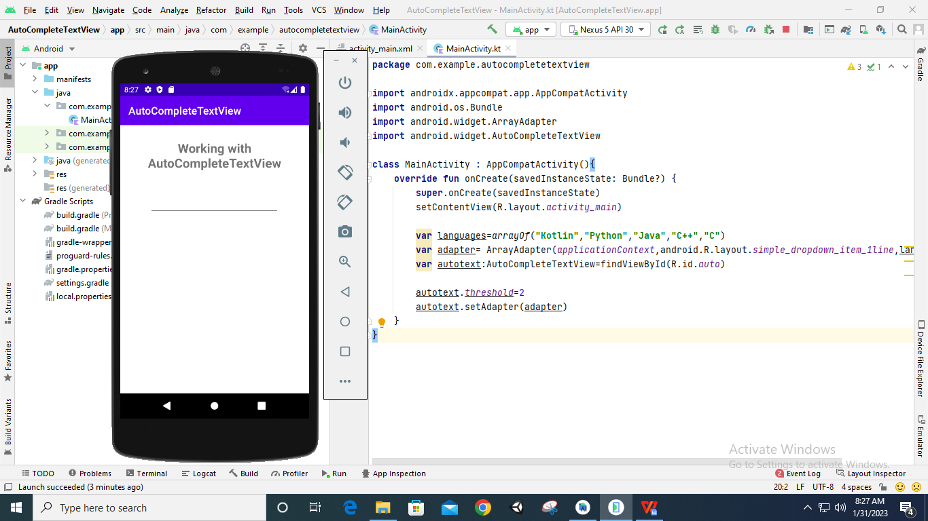

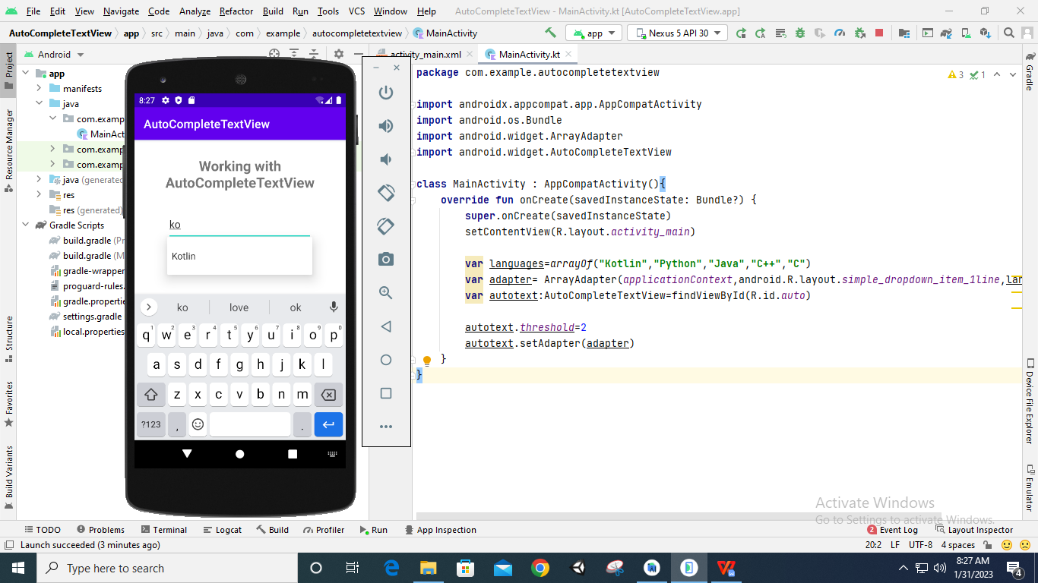

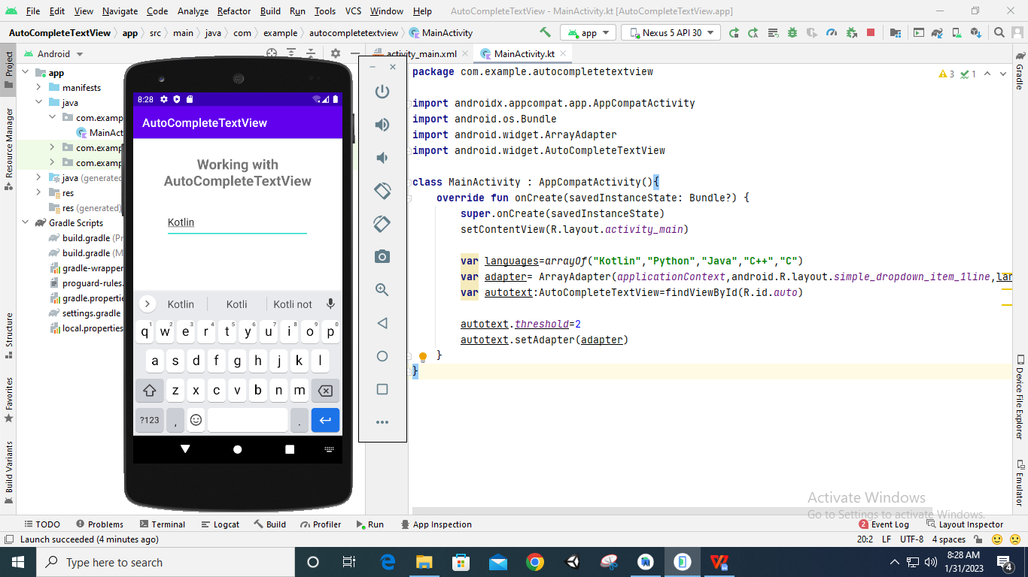

1. **SpinnerView**

**Designing UI**

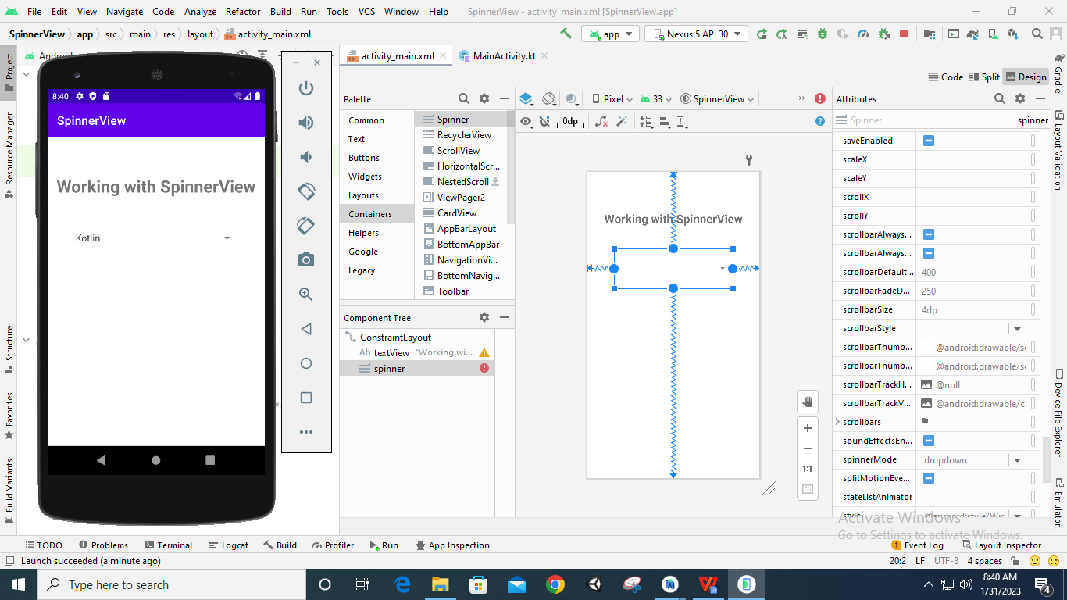

**Code:**

**package** com.example.spinnerview  
  
**import** androidx.appcompat.app.AppCompatActivity  
**import** android.os.Bundle  
**import** android.widget.ArrayAdapter  
**import** android.widget.Spinner  
  
**class** MainActivity : AppCompatActivity(){  
 **override fun** onCreate(savedInstanceState: Bundle?) {  
 **super**.onCreate(savedInstanceState)  
 setContentView(R.layout.*activity_main*)  
  
 **var** languages=*arrayOf*(**"Kotlin"**,**"Python"**,**"Java"**,**"C++"**,**"C"**)  
 **var** adapter= ArrayAdapter(*applicationContext*,android.R.layout.*simple_dropdown_item_1line*,languages)  
 **var** spin:Spinner=findViewById(R.id.*spinner*)  
  
 spin.*adapter*=adapter  
 spin.setAdapter(adapter)  
 }  
}

**Output:**

